Milestones

Milestone 1: UI/UX and Basic User Authentication
- Design Mobile App Interface (UI) — Owen
- Research and Integrate User Authentication Methods — Owen
- Design Registration Form Interface — Owen
- Develop User Database Structure — Andrew

Milestone 2: Backend Server Architecture and Real-Time Communication
- Develop Backend Server Architecture — Andrew
- Document Backend Server Setup and Communication Protocols — Andrew

Milestone 3: Sensor and Parking Spot Detection System
- Test Parking Spot Detection Systems (Motion/Infrared Sensors) — Andrew
- Investigate Sensor Technologies for Detecting Vehicles — Andrew

Milestone 4: GPS Integration and Parking Spot Location
- Specify Parking Spot Location Method Using GPS — Andrew
- Test GPS System Integration — Andrew
- Validate Parking Location Method with Field Tests — Andrew

Milestone 5: Real-Time Data Processing and System Refinement
- Refine Real-Time Data Fetching Process for Parking Availability — Andrew
- Design System for Processing and Updating Parking Spot Data in Real Time — Andrew
- Test Real-Time Server Communication Between App and Database — Owen

Milestone 6: Security and User Data Management
- Specify Security Measures for Protecting User Data — Owen
- Document User Authentication and Database Interaction Process — Owen

Milestone 7: User Experience and Testing
- Test the Mobile App UI Components — Owen
- Validate User Experience Through User Testing Sessions — Owen

Milestone 8: Advanced Data and Sensor Integration
- Research Data Analysis Methods for Sensor Data Processing — Andrew
- Test Data Analysis System for Parking Availability Updates — Andrew

Milestone 9: Scalability and User Feedback
- Assess Database Scalability for Increasing Users — Andrew
- Develop User Feedback Loops for Reporting Parking Issues — Andrew

Milestone 10: Completion and Documentation
- Develop User Guides and Tutorials — Owen
- Document System Processes and Protocols for Future Maintenance — Owen and Andrew

Timeline

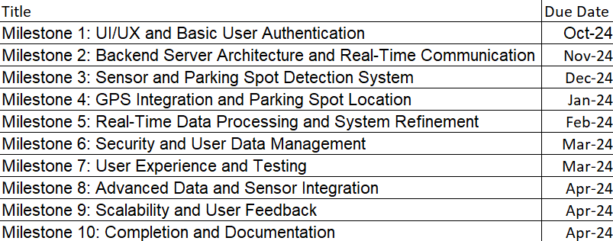
Tabe 1: Timeline of Project

Effort Matrix
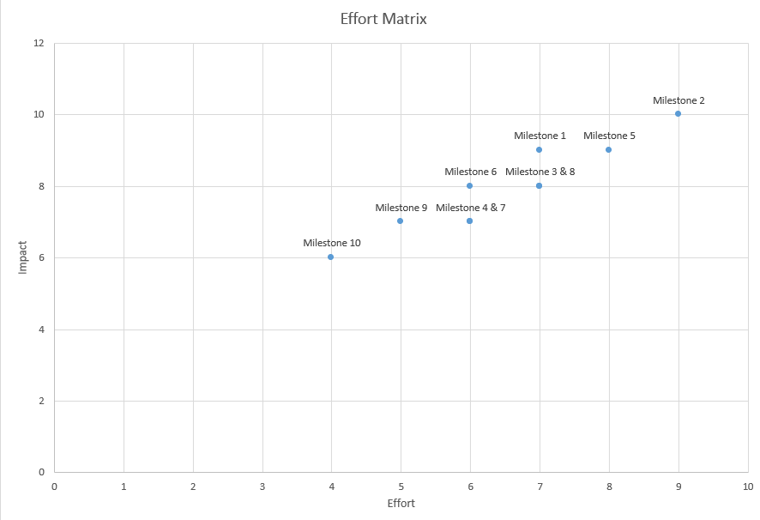
Table 2: Effort Matrix of our Milestones

